**Project Design Phase-II**

**Data Flow Diagram & User Stories**

|  |  |
| --- | --- |
| Date | 03 October 2022 |
| Team ID | PNT2022TMID12466 |
| Project Name | Ai based localization and classification of skin disease with erythema |
| Maximum Marks | 4 Marks |

**Data Flow Diagrams:**

A Data Flow Diagram (DFD) is a traditional visual representation of the information flows within a system. A neat and clear DFD can depict the right amount of the system requirement graphically. It shows how data enters and leaves the system, what changes the information, and where data is stored.

Example: DFD Level 0 (Industry Standard)

**Example:** [**(Simplified)**](https://developer.ibm.com/patterns/visualize-unstructured-text/)

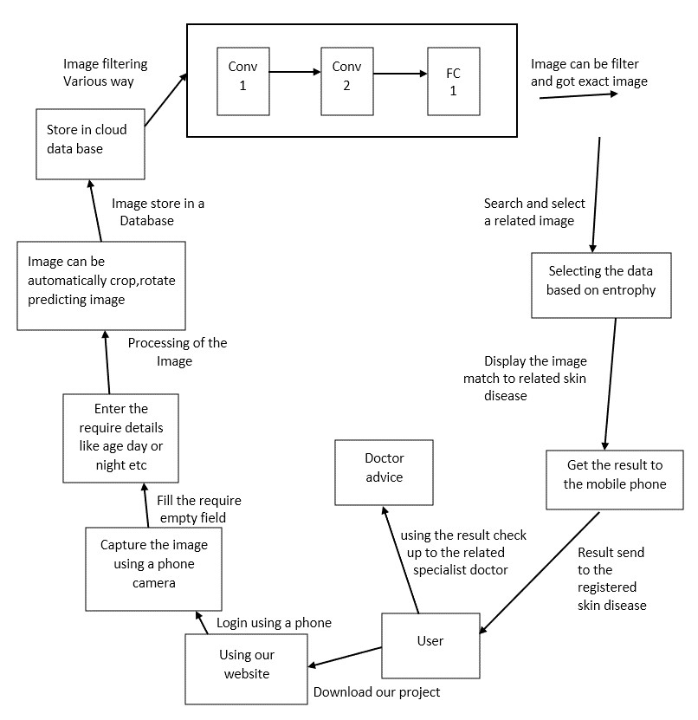

**User Stories**

Use the below template to list all the user stories for the product.

|  |  |  |  |  |  |  |
| --- | --- | --- | --- | --- | --- | --- |
| **User Type** | **Functional**  **Requirement (Epic)** | **User Story**  **Number** | **User Story / Task** | **Acceptance criteria** | **Priority** | **Release** |
| Customer  (Mobile user) | Registration | USN-1 | As a user, I can register for the application by entering my email, password, and confirming my password. | I can access my account / dashboard | High | Sprint-1 |
|  |  | USN-2 | As a user, I will receive confirmation email once I have registered for the application | I can receive confirmation email & click confirm | High | Sprint-1 |
|  |  | USN-3 | As a user, I can register for the application through Gmail | I can register & access the dashboard with Gmail | Medium | Sprint-1 |
|  | Login | USN-4 | As a user , I can log into the application by entering email & password | I can use a login id and password | High | Sprint-1 |
|  | Dashboard | USN-5 | As a user, I can see the configuration in a dashboard and use them | I can use all features in dashboard | Medium | Sprint-2 |
| Customer (Web user) | Register | USN-1 | As a user, I can register for the application entering my email,password and confirming my password | I can access my account/dashboard | High | Sprint-1 |
|  | Login | USN-2 | As a user , I can log into the site by entering email & password | I can use a login id and password | High | Sprint-1 |
| Customer Care Executive | Suggest a doctor | USN-2 | Depend upon the skin disease the doctor can be suggested | Suggest a specialist doctor | Medium | Sprint-2 |
| Administrator | Maintain | USN-1 | A data given by a users are maintained by a administrator | Data is kept in safe | High | Sprint-1 |